AI-DRIVEN COMPLEX EMOTION RECOGNITION USING FACIAL EXPRESSION IMAGES
Methodology, Novelty and Key Contributions
Department of Computer Science and Engineering (Data Science), [COLLEGE NAME]
Batch A16 (CSDS-A) · Academic year [ACADEMIC YEAR]
Table 1: Project team
S.No. | Student name | Roll number
1 | B. Shirisha | 23K91A6730
2 | B. Ashrith | 23K91A6731
3 | B. Murali | 23K91A6724
4 | B. Goutham | 23K91A6727

Project guide: [GUIDE NAME]
Chapter and section numbers quoted in the text (for example Chapter 8 or Section 6.2) refer to the full project report, 17.Final Document. Figures and tables in this document are numbered from 1.

1. METHODOLOGY
This document describes how Mosaic works from end to end and what is new in it. Part 1 gives the pipeline, the data, the algorithms and the reasons they were chosen; Part 2 sets the work against the base paper and separates what is new from what is standard; Part 3 lists the contributions.

1.1 Overall Methodology
The method follows the analysis-by-synthesis idea of the base paper [1]: a generative model synthesises faces that carry two emotions at once, and a multi-label recogniser is trained on real and synthetic faces together. Mosaic realises the idea at a deliberately small scale so that every stage runs on a CPU in minutes. Training is offline and has three stages that share one label order (seven basic emotions followed by eleven compound ones, 18 outputs in all); serving is online and handles one uploaded image per request. The label order is defined once in ml/taxonomy.py, and training, synthesis, inference and the API all import it, so an output index means the same thing everywhere.
1. Load the data (offline): decode the 28,709 training and 7,178 test FER2013 faces, convert to grayscale, resize from 48 by 48 to 64 by 64 pixels.
2. Stage 1, backbone: train a seven-class softmax CNN on the real faces with class-weighted cross-entropy (five epochs). It is the single-label baseline and later the initialiser of the final model.
3. Stage 2, cEmoGAN: train a conditional GAN on a class-balanced subset of 400 real faces per class (2,800 faces, ten epochs); the condition is a seven-element emotion vector.
4. Stage 3a, synthesis: for each of the eleven compound classes draw 200 noise vectors and condition the generator on its two component emotions at weight 0.5 each; label every synthetic face with both basic bits and the compound bit.
5. Stage 3b, final classifier: train the 18-output CNN with binary cross-entropy on the 28,709 real faces (one basic bit each) plus the 2,200 synthetic faces, starting from the backbone's convolutional weights (five epochs).
6. Serve: for each uploaded image, detect the largest face with a Haar cascade, crop it in grayscale, resize to 64 by 64, run the CNN, apply a sigmoid to the 18 logits, sort the basic and compound lists, and report the largest of all 18 scores as the dominant emotion.
7. Evaluate: basic-emotion accuracy and macro-F1 on the FER2013 test set against the single-label baseline, a seeded ablation with and without the synthetic faces, diagnostics of the generator and of the compound outputs, and measurements of the API.
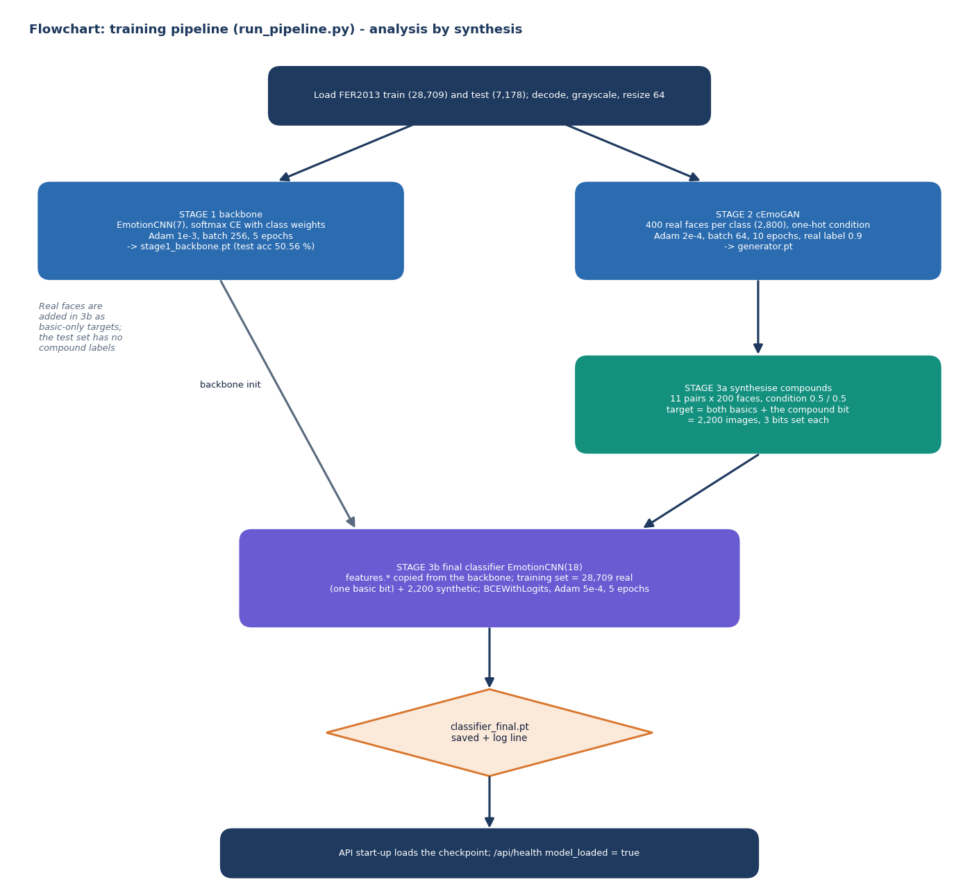
Figure 1: Training pipeline of Mosaic: backbone, cEmoGAN, compound synthesis and the final multi-label classifier.

1.2 Dataset
The data is FER2013 [11], the 48 by 48 pixel grayscale facial-expression set collected for a 2013 machine-learning challenge, in the copy published on the Hugging Face Hub as Jeneral/fer-2013 (tagged apache-2.0 there; the original competition terms are not restated by the mirror, so the licence should be checked before redistribution). The product loads it from two pickled lists, data/train.pt and data/test.pt, whose items are a JPEG byte string and an emotion name. The split is the one shipped by the mirror: 28,709 training and 7,178 test images. There is no separate validation split; the test set is evaluated after every epoch for the log line but nothing is selected on it, because every run trains for a fixed number of epochs and keeps the last weights.
Table 2: FER2013 class counts as loaded by the product
Split | Angry | Disgust | Fear | Happy | Sad | Surprise | Neutral | Total
Train | 3,995 | 436 | 4,097 | 7,215 | 4,830 | 3,171 | 4,965 | 28,709
Test | 958 | 111 | 1,024 | 1,774 | 1,247 | 831 | 1,233 | 7,178

Two properties of the data matter for everything that follows. First, the classes are imbalanced: disgust has 436 training images (1.5 %) against 7,215 for happy, and always predicting happy would score 24.7 % on the test set. Second, FER2013 carries one basic label per image and no compound labels at all. The eleven compound outputs therefore have no real ground truth anywhere in the project: they can be trained only from synthetic faces and can be checked only against synthetic faces. The base paper used three small laboratory sets (CK+ [13], JAFFE and MUG) and built its two-emotion ground truth by morphing pairs of peak frames, which Mosaic does not do; the datasets, the label sets and the evaluation therefore differ, and Chapter 8 compares the two only qualitatively.

1.3 Preprocessing

1.3.1 Training pipeline
ml/dataset.py decodes each JPEG with Pillow into an 8-bit grayscale array, resizes it to 64 by 64 with OpenCV's default bilinear interpolation, and maps the label string to the product's own index. The mapping goes through the string, not through the dataset's integer codes, because the mirror's order (neutral before sad) differs from the product's order. Every training script then scales pixels to the range minus one to one, x = (p / 255 - 0.5) / 0.5, which matches the generator's tanh output. No augmentation (flips, crops, rotations) is applied. For the GAN, cap_per_class=400 keeps the first 400 images of each class, giving 2,800 faces and a perfectly balanced set at the cost of discarding about 90 % of the data.

1.3.2 Serving pipeline
At request time the image is decoded with Pillow, converted to RGB and then to BGR for OpenCV, and passed to detect_largest_face(), which converts to grayscale and calls CascadeClassifier.detectMultiScale with scale factor 1.1, five neighbours and a minimum size of 40 by 40 pixels [23], [29]. The detection with the largest area is cropped from the grayscale image (no margin, no alignment, no histogram equalisation) and goes through the same resize and scaling as in training. The detector's minimum size of 40 pixels is almost as large as a native 48-pixel FER2013 image, so un-enlarged FER2013 faces are not found at all; the measurements in Chapter 8 quantify this and also show that a tight Haar crop is framed differently from the training faces. This training-serving mismatch is a limitation of the design, not of the data.

1.4 Algorithm Choice and Justification
Every algorithm is the smallest one that does the job on the available hardware. The justifications below are the reasons recorded in the code and README, supplemented by the constraints of this project (a CPU-only machine, a one-hour training budget, no compound labels).
Table 3: Algorithms chosen, the reason and the alternative
Component | Choice | Why | Alternative not used
Face detection | OpenCV Haar cascade | ships with OpenCV, no extra download, fast on CPU | MTCNN or a learned detector: more robust, heavier
Recogniser | 4-block CNN, 770,130 parameters | trains in minutes on CPU; same family as the base paper's small CNN | ResNet or ViT transfer learning: stronger, needs pre-trained weights and more compute
Basic-only baseline | softmax + class-weighted cross-entropy | the standard single-label formulation; weights counter the 1.5 % disgust class | focal loss or re-sampling
Multi-label head | 18 sigmoids + BCE | a face may carry two emotions at once, so labels are not mutually exclusive | softmax over 18 classes (forces one label)
Generator | conditional DCGAN (transposed convolutions) | the condition vector lets one model produce every class, as in the base paper's cGAN part | StyleGAN or the base paper's encoder + cGAN for identity-preserving latents
Compound synthesis | 0.5 / 0.5 blend of two one-hot conditions | needs no compound training data; mirrors the base paper's multi-hot condition | morphing real pairs (base paper's ground truth)
Optimiser | Adam | robust defaults for small CNNs and GANs [24] | SGD with momentum
Regularisation | batch normalisation, dropout 0.4 | stabilise training, limit over-fitting of the 256-unit layer [25], [26] | weight decay, data augmentation

One honest difference from the base paper deserves a sentence. The base paper's central contribution is an encoder that maps a face to a latent code so that identity is kept while the label changes the expression. Mosaic's generator takes a random noise vector and a label vector only; it has no encoder and no identity-preservation mechanism, so objective 1 of the batch (identity-preserving generation) is not implemented, and the synthetic faces are random faces with a requested expression, not edited versions of a given face.

1.5 Mathematical Formulation
Notation: an image is x, the true basic class is y, there are K = 7 basic classes and L = 18 labels, n_c is the number of training images of class c, N is the training-set size and z is a noise vector with 100 elements.

1.5.1 Stage 1: weighted softmax cross-entropy
w_c = N / (K · n_c) (1)
p(c | x) = exp(s_c) / Σ_k exp(s_k), L₁ = − w_y · log p(y | x) (2)
The class weights w_c are computed from the training labels (class_weights() in ml/dataset.py). With N = 28,709 and K = 7 the weight of disgust is 9.41 and that of happy 0.57, so a disgust image counts about 16.5 times as much as a happy one in the loss.

1.5.2 Stage 3b: multi-label sigmoid and binary cross-entropy
σ(s) = 1 / (1 + e^(−s)), t ∈ {0, 1}^18 (3)
L₃ = − (1/L) Σ_j [ t_j · log σ(s_j) + (1 − t_j) · log(1 − σ(s_j)) ] (4)
A real face has exactly one basic bit set in t; a synthetic face has the two basic bits of its compound and the compound bit set (three ones). The loss is the unweighted mean over the 18 outputs (BCEWithLogitsLoss, no positive weighting), so a rare positive label contributes little unless the model can separate it. At serving time the score of label j is σ(s_j) and the dominant emotion is the arg-max over all 18 scores; the basic prediction used in the evaluation is the arg-max over the first seven. The multi-label formulation follows [27] and the base paper.

1.5.3 Stage 2: the conditional GAN objective as implemented
L_D = BCE(D(x | y), 0.9) + BCE(D(G(z | y) | y), 0) (5)
L_G = BCE(D(G(z | y) | y), 0.9) (6)
BCE(·, t) is binary cross-entropy with logits against the target t. Two details differ from the textbook minimax game [16], [17]: the real-label target is smoothed to 0.9, and the generator minimises the non-saturating loss against the same smoothed target, not against 1. D receives the image and the condition, the condition being projected to 16 values and concatenated with the 4,096 image features. Both networks use Adam with learning rate 2·10⁻⁴ and β₁ = 0.5. During training the condition y is always a one-hot vector; the blended vector used for compound synthesis never appears in training, which is the weak point of the design analysed in Chapter 8.

1.5.4 Compound condition and labels
y(a, b) = 0.5 · e_a + 0.5 · e_b, t(a, b) = e_a + e_b + e_(a·b) (7)
e_a is the one-hot vector of basic emotion a in the seven-element condition space and e_(a·b) the unit vector of the compound label in the 18-element target space. For example, happily_surprised uses the condition with 0.5 at happy and 0.5 at surprise and the target with ones at happy, surprise and happily_surprised.

1.5.5 Evaluation quantities
F1_c = 2 · P_c · R_c / (P_c + R_c), macro-F1 = (1/K) Σ_c F1_c (8)
d²(μ₁, Σ₁; μ₂, Σ₂) = ‖μ₁ − μ₂‖² + Tr(Σ₁ + Σ₂ − 2 (Σ₁ Σ₂)^(1/2)) (9)
Accuracy and macro-F1 are computed on the 7,178 test faces with scikit-learn. The second formula is the Fréchet distance between two Gaussians [21]; the project applies it to the 256-unit hidden layer of the stage-1 CNN, not to Inception features, to compare generated faces with real ones. It is a diagnostic of this project's own models and is not comparable with published FID values. The multi-label scores of the base paper (f-beta and exact-match ratio) are also computed on a synthetic hold-out set in scripts/run_experiments.py.

1.6 Model Architecture and Training

1.6.1 The recogniser
EmotionCNN has four convolution blocks that halve the resolution each time (64 → 32 → 16 → 8 → 4) while growing the channel count from 1 to 128, followed by a 256-unit hidden layer and an output layer. The same class serves as the 7-output backbone (767,303 parameters) and the 18-output final model (770,130 parameters); only the last layer differs, so the backbone's features.* weights (240,960 parameters) can initialise the final model.
Table 4: Layers of EmotionCNN with 18 outputs
# | Layer | Output shape | Parameters
1 | Conv 3×3, 1 → 32, BatchNorm, ReLU, MaxPool 2 | 32 × 32 × 32 | 384
2 | Conv 3×3, 32 → 64, BatchNorm, ReLU, MaxPool 2 | 64 × 16 × 16 | 18,624
3 | Conv 3×3, 64 → 128, BatchNorm, ReLU, MaxPool 2 | 128 × 8 × 8 | 74,112
4 | Conv 3×3, 128 → 128, BatchNorm, ReLU, MaxPool 2 | 128 × 4 × 4 | 147,840
5 | Flatten, Linear 2,048 → 256, ReLU, Dropout 0.4 | 256 | 524,544
6 | Linear 256 → 18 (7 in the stage-1 backbone) | 18 | 4,626
 | Total |  | 770,130

1.6.2 The generator and the discriminator
The generator maps the 107-element input (100 noise values plus the 7-element condition, reshaped to 1 × 1) through five transposed convolutions to a 64 by 64 image with a tanh output: 1,128,353 parameters. The discriminator has four strided convolutions (32, 64, 128, 256 channels, LeakyReLU 0.2) whose 4,096 features are concatenated with the condition projected to 16 values and mapped to one logit: 694,257 parameters. Only the generator is used afterwards.
Table 5: Layers of the conditional generator
Layer | Output shape | Parameters
ConvTranspose 4×4, 107 → 256, BatchNorm, ReLU | 256 × 4 × 4 | 438,528 + 512
ConvTranspose 4×4 stride 2, 256 → 128, BatchNorm, ReLU | 128 × 8 × 8 | 524,416 + 256
ConvTranspose 4×4 stride 2, 128 → 64, BatchNorm, ReLU | 64 × 16 × 16 | 131,136 + 128
ConvTranspose 4×4 stride 2, 64 → 32, BatchNorm, ReLU | 32 × 32 × 32 | 32,800 + 64
ConvTranspose 4×4 stride 2, 32 → 1, Tanh | 1 × 64 × 64 | 513

1.6.3 Training configuration
Table 6: Training configuration copied from the defaults of the three training scripts
Item | Stage 1 backbone | Stage 2 cEmoGAN | Stage 3 final classifier
Script | train_classifier_stage1.py | train_gan.py | train_final_classifier.py
Training images | 28,709 real | 2,800 real (400 per class) | 28,709 real + 2,200 synthetic
Targets | class index (7) | one-hot condition (7) | multi-hot (18)
Loss | weighted cross-entropy | BCE-with-logits, real label 0.9 | BCE-with-logits
Optimiser | Adam, lr 1·10⁻³ | Adam, lr 2·10⁻⁴, β = (0.5, 0.999) | Adam, lr 5·10⁻⁴
Batch size | 256 | 64 (last partial batch dropped) | 256
Epochs | 5 | 10 | 5
Initialisation | random | random | features.* from stage 1
Seeds, augmentation | not set, none | not set, none | not set, none
Device | CPU | CPU | CPU
Logged result | test accuracy 50.56 % | final losses D 0.7731, G 3.7240 | test accuracy 58.14 % (basic outputs)

The product's own training_log.txt records those three result lines. Stage 3 had not been run when the project was received (the final checkpoint was missing and the API reported that no model was loaded), so it was run for this report with the unchanged script on the shared CPU-only Windows PC used for the work: epochs took 153, 126, 129, 115 and 97 seconds (10 minutes 37 seconds in total). The scripts do not set random seeds; to make the comparisons in Chapter 8 repeatable, scripts/run_experiments.py re-trains the final classifier with explicit seeds for the with-synthetic and without-synthetic variants.

1.6.4 Evaluation protocol
• Basic emotions: accuracy, macro-F1, per-class precision, recall and F1 and the confusion matrix on the 7,178 test faces, for the stage-1 baseline and the final model (arg-max over the seven basic outputs).
• Ablation: the final classifier trained with and without the synthetic faces, same initialisation and epochs, several seeds, plus a sweep over the number of synthetic faces per compound class.
• Compound outputs: their scores on real test faces, and the multi-label metrics (micro- and macro-F1, exact-match ratio, ROC-AUC) on 1,100 freshly generated hold-out faces, with a real-data-only control. Because the hold-out comes from the same generator that produced the training faces, it measures whether the classifier learned the generator's labels, not whether it recognises real compound expressions.
• Generator: how often the stage-1 classifier reads a generated face as the requested emotion, and the Fréchet distance in its feature space.
• Serving: Haar detection rate by image size, accuracy through the serving path against direct resizing, API latency and malformed-input probes, and the automated tests.

2. NOVELTY AGAINST THE BASE PAPER

2.1 What the base paper does
The base paper [1] proposes analysis by synthesis for complex emotion estimation. Its generator, cEmoGANs, combines an encoder that maps a face to an identity-bearing latent vector with a conditional GAN driven by a six-dimensional multi-hot emotion label; blended labels (for example happiness plus surprise) are used to synthesise complex expressions while keeping identity. A small CNN with sigmoid outputs is then trained on the generated images. It is evaluated on CK+, JAFFE and MUG (laboratory datasets; MUG peak frames, morphed to create two-emotion ground truth). Its result: f-beta 0.99 / 0.99 / 0.80 and exact-match ratio 100 % / 99 % / 68.7 % on CK+ / JAFFE / MUG, measured on a 7:3 split of 15,000 images generated by the same cEmoGANs (EfficientNet-B0 baseline: f-beta 0.45 / 0.60 / 0.51). Image quality is reported with an Inception score, a Fréchet inception distance and BRISQUE; identity is checked with a face-recognition cosine similarity (98 % (CK+), 94 % (JAFFE), 99 % (MUG) of generated images with identity cosine similarity above 0.7).
Training used Intel i9-9900K, NVIDIA RTX A6000. Unconstrained photographs are tested only qualitatively, against Py-Feat.

2.2 What Mosaic adds and what it simplifies
Table 7: Mosaic against the base paper
Aspect | Base paper | Mosaic
Goal | Estimate complex emotions from a face by analysis by synthesis | The same idea built as a working product: accounts, upload and webcam, history
Generator | cEmoGANs: encoder for identity + conditional GAN, learning rates 1e-4 / 1e-5 | Conditional GAN only (1,128,353 parameters), no encoder, one-hot conditions, Adam 2e-4, 10 epochs
Condition for compounds | Two active bits of a 6-d label; training images are morphed pairs | Seven-dimensional soft vector, 0.5 on each component, used only at synthesis time
Data | CK+, JAFFE, MUG (laboratory); 15,000 generated images | FER2013 (28,709 train, 7,178 test, uncontrolled 48x48); 2,200 generated images
Classifier | Small CNN, sigmoid outputs; EfficientNet-B0 baseline | Four-block CNN, 18 sigmoid outputs (770,130 parameters); single-label CNN baseline
Labels | Six basic emotions, 15 complex types | Seven basic (with neutral) and 11 compound types
Reported result | f-beta 0.99 / 0.99 / 0.80 and exact match 100 % / 99 % / 68.7 % on generated test images | Basic accuracy 58.14 % on real test faces; compound outputs at chance on synthetic faces
Controls | EfficientNet-B0 and StyleGAN-trained models | Seeded real-only control (3 seeds) and a threshold sweep on a synthetic hold-out
Serving path | None | Haar detection, FastAPI, JWT, SQLite history, Next.js UI; detection and framing study

The datasets, label sets and evaluation protocols differ, so the table compares designs, not scores.

2.3 What is new here and what is not
• New in this project relative to the base paper: a complete, tested application around the idea; an honest measurement layer that includes a seeded real-only control, a synthetic hold-out with a threshold sweep, a conditional-fidelity check of the generator and a study of the Haar serving path; and the documented finding that, at this scale, the generated faces neither help basic recognition nor teach the compound outputs.
• Not new: the conditional GAN [17], the convolutional classifier, multi-label learning with sigmoid outputs [27], the compound-emotion taxonomy [9], FER2013 [11], and the Viola-Jones cascade [23].
• Not carried over from the base paper: the identity encoder, the morphed-pair ground truth, the Inception and FID evaluation, and the action-unit analysis. Objective 1 of the batch (identity-preserving generation) is therefore not met.
Related work is consistent with this reading. Disentangling GANs separate identity from expression for single-label recognition [2], [4]; compound recognition on real data has so far relied on real compound labels, for example RAF-DB [12] in the ABAW7 ensemble [7]. Galkaduwa [6] reports 51.6 % for a light CNN on FER-2013, close to the 50.56 % of Mosaic's single-label baseline; the splits and training budgets may differ, so this is a sanity check, not a comparison.

3. KEY CONTRIBUTIONS
The project makes six contributions. Each is stated with the measurement that supports it; none claims more than the measurements show.
1. A complete analysis-by-synthesis pipeline in one repository. Face detection, a 7-class backbone, a conditional GAN, synthesis of 2,200 compound faces and an 18-output multi-label classifier, trainable with one command (python -m app.ml.run_pipeline) and served by a FastAPI application.
2. A usable emotion-analysis product. JWT accounts with bcrypt hashing, optional-auth analysis, per-user history with thumbnails, a Next.js console with an upload and webcam capture widget, a basic-emotion chart and compound bars; median analysis time 19.3 ms on the test PC.
3. A controlled test of whether generated faces help. A seeded real-only control (seeds 1 to 3): 58.10 ± 1.59 % without and 58.86 ± 0.57 % with synthetic faces, so the effect on basic accuracy is not distinguishable from noise; A single-seed sweep of the number of synthetic faces per compound class gives 57.77 % accuracy and 0.515 macro-F1 at 50, 58.28 % accuracy and 0.526 macro-F1 at 200 and 58.41 % accuracy and 0.559 macro-F1 at 800 (seed 1 throughout), so no dose-response is visible.
4. An evaluation of compound outputs that does not need real compound labels. Behaviour on 7,178 real faces, a synthetic hold-out scored by ROC-AUC and a threshold sweep, and a conditional-fidelity and Fréchet-distance check of the generator. Together they show the compound head is inert (0.00019 on real faces, AUC 0.497 on synthetic).
5. A serving-path study. Haar detection finds 0 % of native faces and 56.5 % after upscaling, and accuracy falls from 66.2 % to 55.8 % on the faces it finds, which identifies training/serving mismatch as a first-order weakness.
6. Tests, probes and documentation. 28 pytest tests, 24 malformed-input probes with timings, eleven diagrams, 19 real screenshots, and a list of nine defects found in the product.
What the contributions do not include: a new learning algorithm, identity-preserving generation, a new dataset, or evidence that compound emotions are recognised on real faces.

